PROG8450 LAB2

Fei Yun

8680643

1

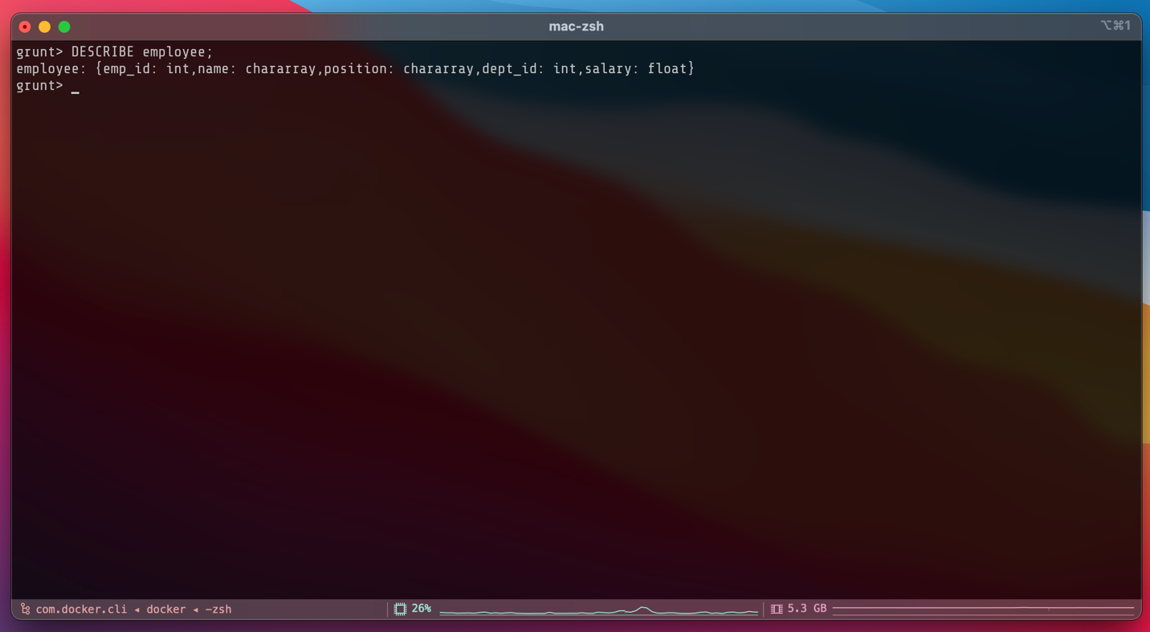

3

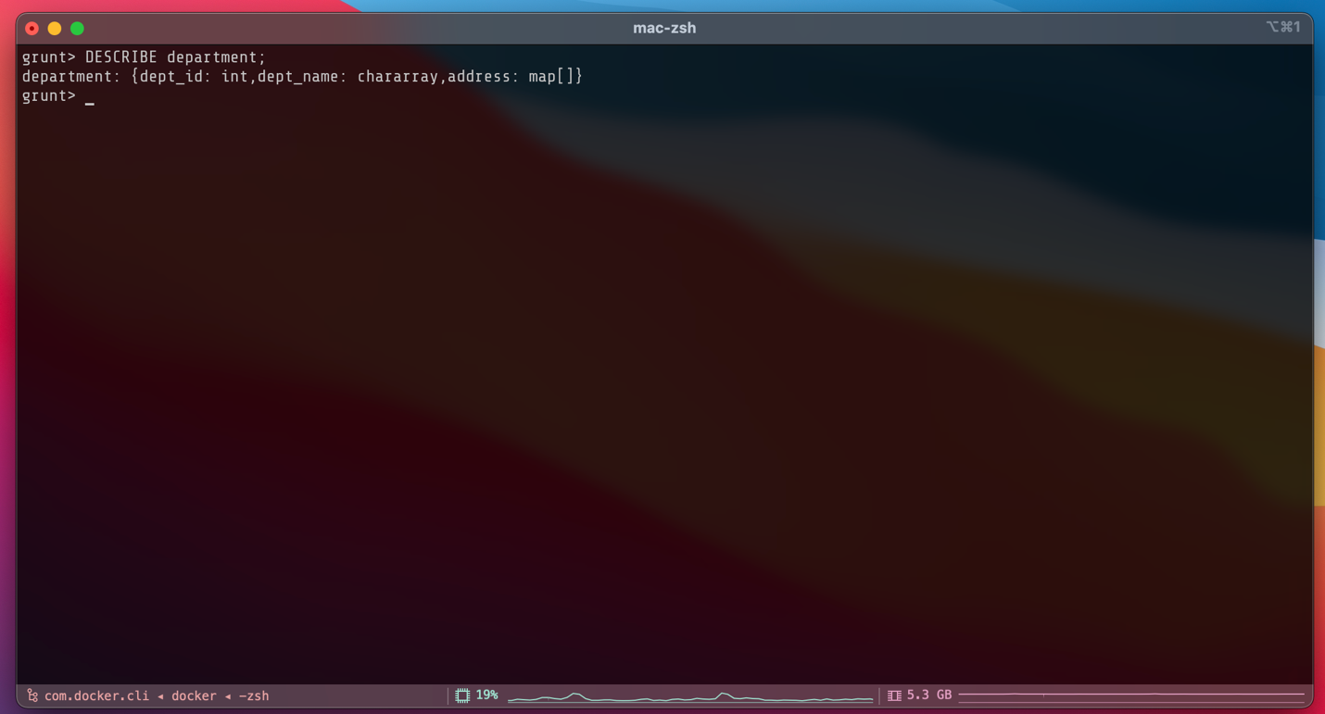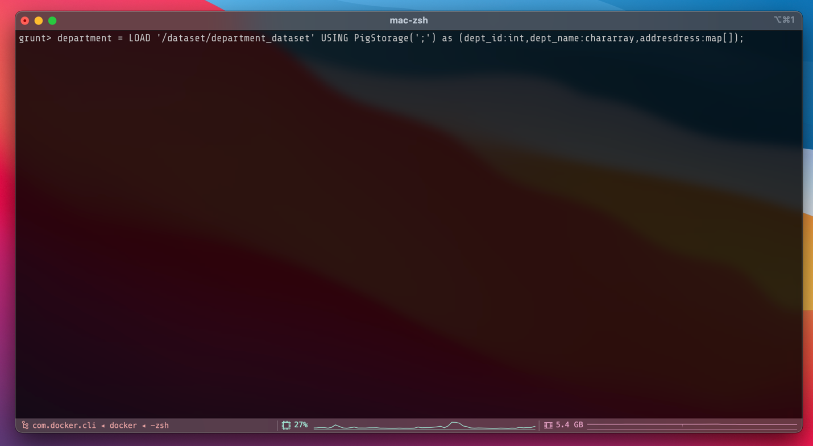

5

6

7



